Black Friday sales prediction

**PROJECT REPORT**

**Submitted by**

**Software changes**

T Naveen kumar

M Haritha

N Keerthi Reddy

K Anusha

K Pavithra

***In partial fulfilment for the award of the Certificate***

**of**

**SUMMER INTERNSHIP PROGRAM**

                 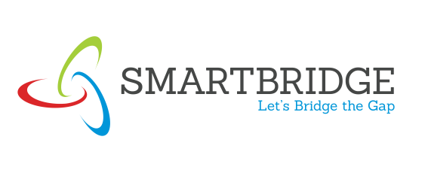

**Department of Computer Science and Engineering**

**Annamacharya Institute of Technology and Sciences**

**Venkatapuram Village , Renigunta Mandal , Tirupati , Andhra Pradesh 517520**

**July 2019.**

### BONAFIDE CERTIFICATE

This is to certify that the project entitled ”**black Friday sales prediction**” submitted by T Naveen kumar,M Haritha,N Keerthi Reddy,K Anusha,K Pavithra

in partial fulfilment for the requirements for the award of internship certification in technologies of Machine learning and Deep learning is an authentic work carried out by them under my supervision and guidance.

To the best of my knowledge, the matter embodied in the project report has not been submitted to any other University/Institute for the award of any Degree or Diploma.

### Signature of Supervisor                                            Signature of Head of the Department

   Akshay Kumar Kothuri, M.Tech                                 Mrs.B.Rupa Devi M.Tech,Ph.D.,

  AI & IoT Developer         Assistant Professor & HOD,

  SmartBridge Educational Services PVT LTD                   Department of CSE,

  Hyderabad – 500096                                                          AITS,Tirupati.

Index

1.Title of the project

1.1 Introduction

1.2 Objective of Research

1.3 problem statement

1.4 industry profile

2.Review of literature

3.Data Collection

4.Methodology

4.1 Exploratory Data Analysis

4.2 Statistical techniques and visualization

4.3 Data Modeling and Suggestions

5.Findings and Suggestions

6.Conclusion

Introduction

Black Friday is November 23, 2018, this year, and the sales are expected to be better than ever. While Thanksgiving remains somewhat of the official start of Black Friday, the deals will actually begin in early November.

Our purpose at BestBlackFriday.com remains the same — to better your Black Friday experience. Our annual predictions are meant to be your first tool to tackle this year’s holiday shopping season. They will tell you when to expect the most popular Black Friday ad scan leaks, where to find the best deals, and other insider tips and tricks.

In a hurry? You can simply read our Cliff Notes Infographic to get a general overview of our predictions and to see the most important data points. For a richer experience, we recommend reading the infographic in addition to the Black Friday Predictions by Category. Each individual article focuses on a specific category and includes additional tips to save more. At the bottom of this article, you can find our 14 general Black Friday 2018 predictions and tips. While there may be a few deals in these very early pre-Black Friday sales, we recommend waiting until at least the second week of November to really starting shopping, and even then you should exercise caution. Our favorite early sale is the annual Sam’s Club Lowest Prices of the Season One-Day Event. We expect this sale to take place on Saturday, November 10 this year, and it will likely be a preview for some of this year’s hottest doorbuster prices on electronics. For example, expect the first real iPhone deal to be available during that sale..

Python

On average, shoppers expect to spend $1,007.24 each. Of that, they'll spend $637.67 on gifts. Another $215.04 will go for food, decorations, flowers, and greeting cards. They'll also spend $154.53 to take advantage of the seasonal deals and promotions.

Here are the past 15 years of [retail sales](https://www.thebalance.com/u-s-retail-sales-statistics-and-trends-3305717) data. The average annual increase is 2.5 percent, thanks to the steep 4.6 percent decline in 2008. Before the [2008 financial crisis](https://www.thebalance.com/2008-financial-crisis-3305679), the 10-year average annual increase was 3.5 percent.

Python can be used as the script in Microsoft's Active Server Page (ASP) technology. The scoreboard system for the Melbourne (Australia) Cricket Ground is written in Python. Z Object Publishing Environment, a popular Web [application server](https://searchsqlserver.techtarget.com/definition/application-server), is also written in the Python language.

**Machine learning**

Machine learning is an application of artificial intelligence (AI) that provides systems the ability to automatically learn and improve from experience without being explicitly programmed. **Machine learning focuses on the development of computer programs** that can access data and use it learn for themselves.

The process of learning begins with observations or data, such as examples, direct experience, or instruction, in order to look for patterns in data and make better decisions in the future based on the examples that we provide. **The primary aim is to allow the computers learn automatically** without human intervention or assistance and adjust actions accordingly.

**Methods**

## . 1. Linear Regression

It is one of the most widely known model technique. Linear regression is usually among the first few topics which people pick while learning predictive model. In this technique, the dependent variable is continuous, independent variable(s) can be and nature of regression line is linear.

Linear Regression establishes a relationship between **dependent variable (Y)** and one or more **independent variables (X)** using a **best fit straight line**

## 2. Logistic Regression

Logistic regression is used to find the probability of event=Success and event=Failure. We should use logistic regression when the dependent variable is binary (0/ 1, True/ False, Yes/ No) in nature. Here the value of Y ranges from 0 to 1 and it can represented by following equation.

## 3. Polynomial Regression

A regression equation is a polynomial regression equation if the power of independent variable is more than 1. The equation below represents a polynomial equation

4.Random forest regression

## Featured snippet from the web

**Random forests** or **random decision forests** are an ensemble learning method for classification, **regression** and other tasks that operates by constructing a multitude of **decision** trees at training time and outputting the class that is the mode of the classes (classification) or mean prediction (**regression**) .

**Problem statement**

The nice thing about this dataset is its simple and clear features. Figure 1 shows a snapshot of the training dataset.

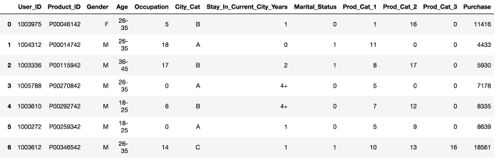

Data collection

Black Friday just around the corner, retail stores are gearing up for both in-store and online sales. But have you ever wondered how these sales are chosen and how retail stores can afford to sell their inventory for such low prices? Are the deals worth it and which day has better sales?

Here’s how retail stores use data to project sales and set prices on Black Friday and Cyber Monday and what to expect this year.

**How it works**

Retail stores have been using historical data to track sales trends since before Cyber Monday was a thing. However, with the rise of big data and online sales- data science can now not only track historical data but do predictive analytics for sales and stay ahead of the trends.

As online consumers browse through sites, like Amazon, the e-retailer tracks items viewed, purchased, added and removed from the cart, viewed on mobile or desktop and more to determine customer behavior across the site. Analytics [help to drive algorithms](https://www.digitalcommerce360.com/2016/11/12/science-behind-black-friday-and-cyber-monday-pricing/) to build, test and predict which customers are more likely to purchase and what products will produce the highest number of revenue through purchase trends, customer behavior, item popularity and profit margins. Products are ranked for how likely a customer is to buy in a short-term sale and based on the interest shown of those items in the past.

The discounts are determined by the machine learning for predicted sales and how much volume purchased on the product would still produce ROI. The data can also be used for the rest of the year to determine how to make up for the discounts around the holidays. They can increase prices on certain high-interest items to compensate for the discounts.

Node Red

### **Browser-based flow editing**

Node-RED provides a browser-based flow editor that makes it easy to wire together flows using the wide range of nodes in the palette. Flows can be then deployed to the runtime in a single-click.

JavaScript functions can be created within the editor using a rich text editor.

A built-in library allows you to save useful functions, templates or flows for re-use.

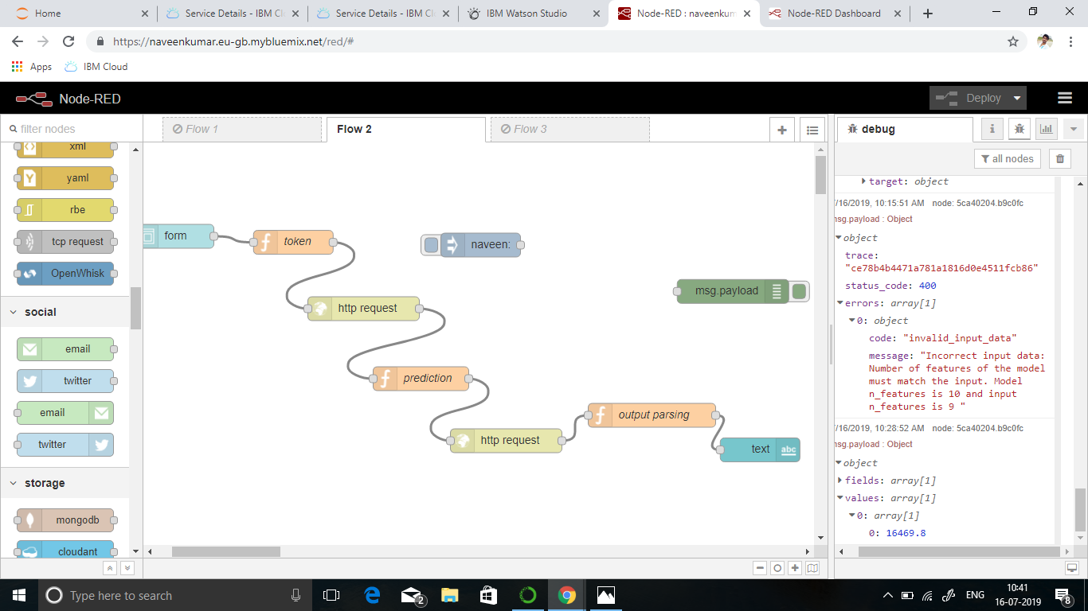

Prediction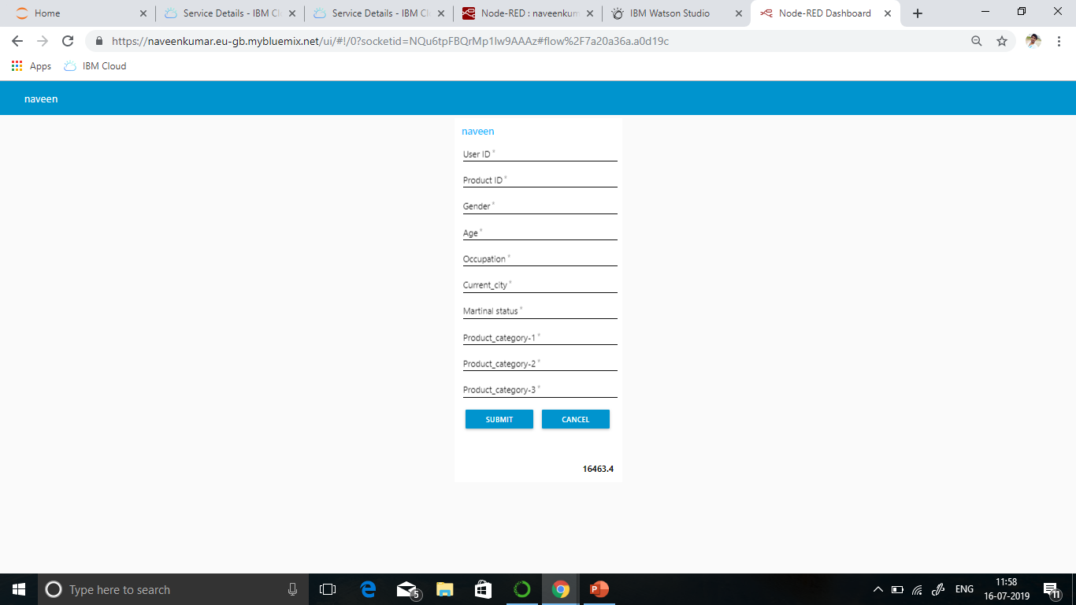

Conclusion

If you want to know if your Black Friday sale has been a success and want to know what made it into a success, you need data to compare the data you’re collecting during the sale with. Make sure you’re currently tracking all the data you need that makes you able to analyze your visitor’s behavior on your site. Start with writing down a measurement and implementation plan and check if all tracking is in place. After the sale is over, compare the data of the BFCM sale with your prior data and check what worked and what didn’t work so you’ll know what to do next time! You don’t have much time, so get crackin’! Happy analyzing!